**UNIDAD UNO**

* **Actividad Dos**
* **Inglés básico**

Vía telefónica:

**TOURISM PROMOTION**

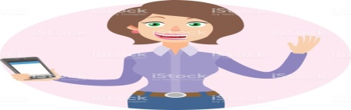

Hello my name is Ingrid Jurenny Galindo Bernal. I´m fourteen years old, my profession is to be a tourist guide, I am an inhabitant of the municipality of Otanche Boyacá. Welcome to the Otanche Boyacá tourist attention line,through this line boy to help you with your questions. ¿how can i help you?. It communicates with the main road with the municipality of Chiquinquira and Puerto Boyacá. The municipality has different ecological activities such as hiking, climbing, diurnal and nocturnal cycling, swimming. We have a frequently warm climate act to perform the aforementioned sports. We offer the following typical foods of the región (sancocho,chicken,mute). The municipality of Otanche Boyacá has several tourist sites that make the municipality as pleasant as are the natural park of the serranías de las quinchas, aquatic reservoirs such as the lagoon of eight, the lagoon of Leticia, the crystalline, waterfalls and the caves of the poop. I hope you liked the information and thank you for your time.  